**Address:**

7740 E Heatherbrae Unit 23

Scottsdale, AZ 85251

# Property Inspection Log:

**Date of Notes:** 1/4/205

**Next Inspection Scheduled:**

* Return coffee maker to Target
* More q tips and cotton pads

Breezeway:

**Smart lock 9180**

**Lockbox with backup key:** 8851 (located on front door - do not share unless needed)

**Parking:** Covered parking is reserved. Our designated space is “23”. Street parking is free. DO NOT park in any other covered parking space or you risk being towed.

**Internet**

Setup-B4F6

Dozed3929around

*There is a screen door with an inside lock. If this door is accidentally locked, we have a spare key stored in the outside cleaning closet at Heatherbrae #1. The cleaning closet can be accessed using the key in the lockbox at Heatherbrae #1.

Inte4rnal access:

9180, 1578

​​**Guest Guide:**<https://docs.google.com/document/d/1EbYOF954Fi-aXnxQPvfhpYTR5p4l0dEVqCHkcUHrO4Q/edit>

**Guest Messaging Guide:**

<https://docs.google.com/document/d/16qBEfvNvXssen6w8ewwPsNpatKLuUd0dn8dHKpjoDGA/edit>

**Trash:**Dumpsters are located in the parking lot, across the courtyard, and through the gate.

**Pet fee:** $120 case by case, the condo is not pet friendly, however, we may accept certain pets if it's a high paying guests with a good track record.

**Scottsdale Trolley:**

<https://www.scottsdaleaz.gov/Assets/ScottsdaleAZ/Trolley/maps/mlhd.pdf>

<https://www.scottsdaleaz.gov/Assets/ScottsdaleAZ/Trolley/maps/trolley-map.pdf>

**Closest stop:**

* MLHDGR Senior Center
* 5 minute walk
* Across from Merci French Cafe

For problems with the dryer turning off and not getting hot, the water tray needs to be emptied.

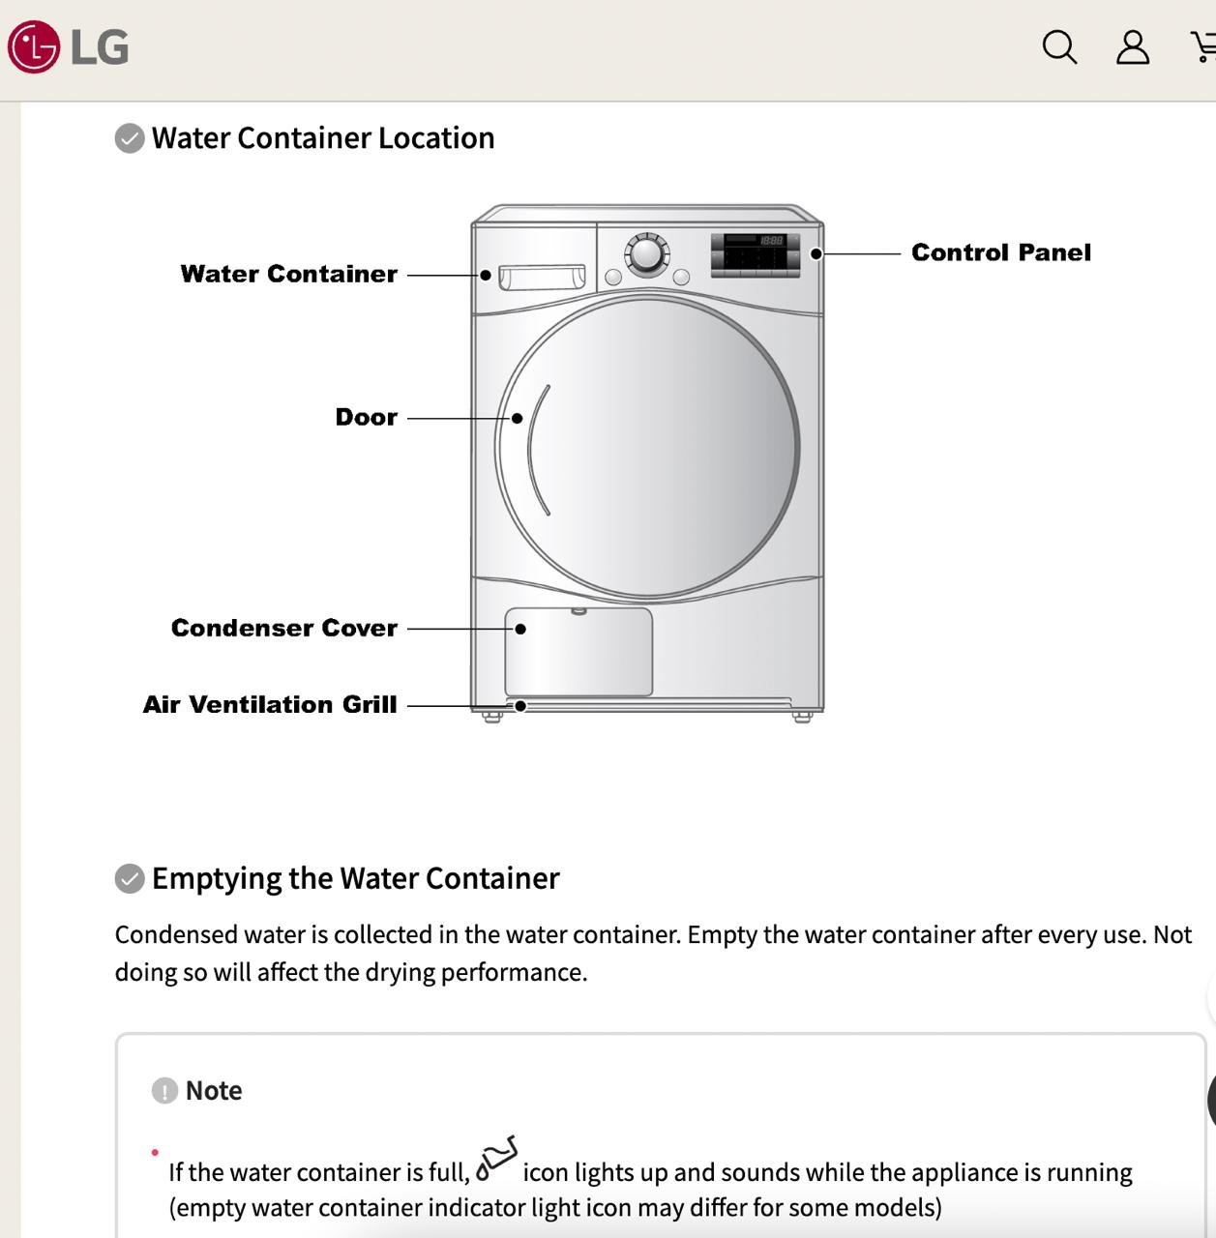

v

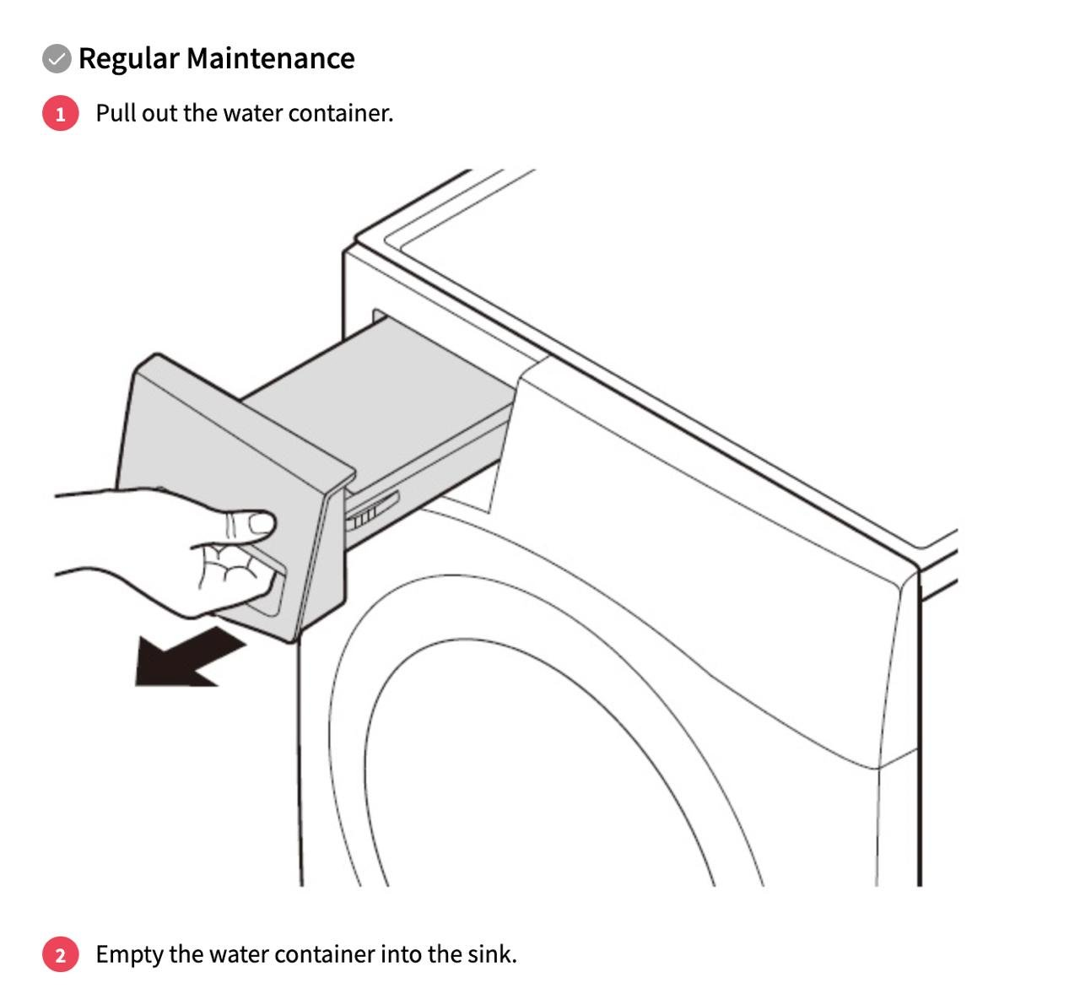

# Restock strategy:

* W&G?
* Any special items different to our standard?

# Guest Access

* **Access Code:**
  + **Schlage Smart Lock:** A unique code generated for each guest (access Smartlock in Hospitable “Devices”)
  + **Backup Key / Lock out strategy:**
    - XXX
* **Garage access:** 
  + xxx
* **Cleaning closet:**

# Wi-Fi Information

* **Network Name:** XX
* **Password:** XX
* **Notes:**
  + Internet provider
  + **Account Email:** XX
  + **Account Number:** XX

# House Notes

### Guest Guide

* XX
* **Guest Messaging Guide:** [Google Doc Link](https://docs.google.com/document/d/16qBEfvNvXssen6w8ewwPsNpatKLuUd0dn8dHKpjoDGA/edit)

### Good to know

* Ie: Where something is that is often misplaced by guests, how to work something that is often asked about

### Trash & Recycling:

* XX
* XX
* *Auto message is scheduled in Hospitable to send to guests ______ night to take out the trash

### 

### AC Filter Size & change frequency:

* XX

### Breaker Box:

* Breaker box is located ________

### 

### Mail:

* XX
* XX

### 

### Commonly asked about amenities:

* **Firepit:** XX
* **Grill:** Propane or charcoal?
* **Backyard:** Fully fenced? What amenities?
* **Pack n play:** Location. Sheets?
* **Coffee maker**: Type? Type of coffee provided?
* **TV:** Smart TV? What apps?

### Pet Policy:

* XX

# Smart Home Devices:

### 

### Thermostat:

* + **Device:** XX
  + **Login:** XX
  + **Password:** XX

### 

### Security Camera:

* **Location**
* **Access:**
  + Access on a phone/iPad app
  + Log in info:

# Cleaning:

* **Primary Cleaner:** XX
* **Scheduling:** XX
* **Extra Jobs:** XX

# Handyman / Maintenance:

* **XX**
  + XX
* **Landscaping:**
  + XX
* **Pest Control**
  + XX
* **HVAC**
  + XX
* **Plumbing**
  + XX

# 